Calculating PPM

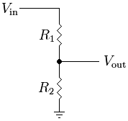

The circuit is setup as a voltage divider, with one channel of potentiometer as R­1 and one sensor as R2.

Vin is the 5V from the Arduino

Vout measured by the Arduino ADC using analogRead()

R1 is the AD5206 digital potentiometer ranging from 0 – 100kOhms, with 8-bits of precision controlled using SPI via the Arduino.

Equation for measuring R2:

1. Set and match the potentiometer as closely as possible to the sensor
2. Take an initial reading plug into 🡺 and save the initial resistance of the sensor
3. Continue taking readings and calculate the percent change in resistance
4. Plug into 🡺 where x is the change in percent